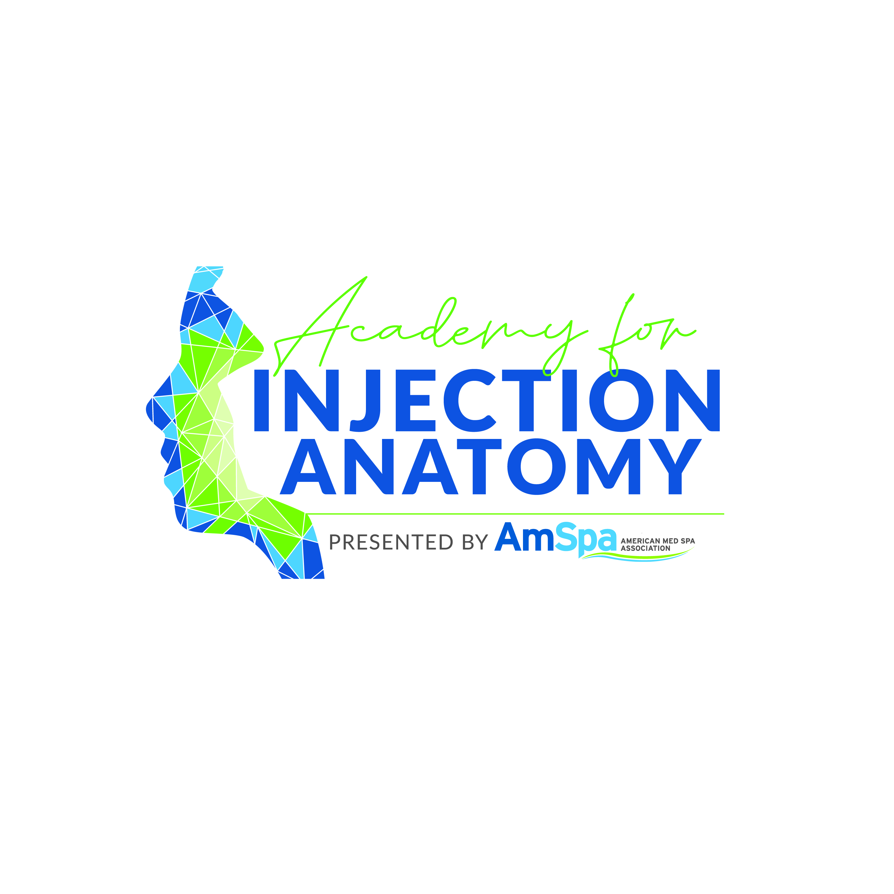
- Academy for Injection Anatomy
- Medical Spa Show, Las Vegas Sunday, April 12, 2026
-  “This activity is jointly provided by Global Education Group and American Med Spa Association.”
- This activity is supported by educational, in-kind grants of neurotoxins, provided by Galderma.
- This activity is supported by educational, in-kind grants of fillers, provided by Galderma.

Target Audience
This activity has been designed to meet the educational needs of physicians, nurses, APRNs, Pas, and other professionals involved in the care of patients searching for non-invasive medical aesthetic treatments.

Statement of Need/Program Overview
The sessions are designed to increase participants knowledge and competence and give them techniques that can be directly applied to their performance in their practice to increase positive patient outcomes and avoid complications using the latest advances in treatment.
Educational Objectives
After completing this activity, the participant should be better able to:
- Identify the anatomical areas prone to adverse events if neurotoxin or dermal fillers are injected improperly.
- Recognize the three-dimensional architecture of the face as it is related to facial injection procedures.
- Cite the rheological properties in Hyaluronic Acid (HA) fillers.
- Discuss the complications from dermal filler injections.

Outline the topographic vascular anatomy of the facial artery and the superficial temporal artery.

Describe the ligamentous and layered anatomy of the temple, tear trough, midface, lips, and jawline.

Discuss the fat compartments of the face relative to facial injection procedures including the unique behavior of the deep and superficial fat compartments during the aging process.

Describe the layered anatomy of the nose with particular emphasis on the SMAS (Superficial Musculoaponeurotic System) and the vasculature.

Identify potential risk factors of patients to minimize filler complications.

Demonstrate how to use ultrasound to evaluate an aesthetic patient.

Recognize how to identify various tissues (skin, muscle, fat, bone, vessels) with ultrasound.

Faculty
Christopher C. Surek, D.O., FACS
George Baxter-Holder, DNP, ARNP, CANS, ISPAN-F
Hermine Warren, DNP, APRN, CANS, ISPAN-F, CNM
Anita Wolf, RN

Program Agenda
AIA Cadaver Training | Medical Spa Show 2026

Physician Accreditation Statement
This activity has been planned and implemented in accordance with the accreditation requirements and policies of the Accreditation Council for Continuing Medical Education (ACCME) through the joint providership of Global Education Group (Global) and American Med Spa Association. Global is accredited by the ACCME to provide continuing medical education for physicians.
Physician Credit Designation
Global Education Group designates this live activity or a maximum of 6.75 AMA PRA Category 1 Credits™. Physicians should claim only the credit commensurate with the extent of their participation in the activity.
ANCC typically accepts certificates of participation for educational activities certified for AMA PRA Category 1 Credit™ pending from organizations accredited by ACCME. Please check with your board of nursing for further details.

Global Contact Information
For information about the accreditation of this program, please contact Global at 303-395-1782 or cme@globaleducationgroup.com.

Instructions for Obtaining Credit
To be announced

Fee Information& Refund/Cancellation Policy
- All registration fees are in U.S. dollars. Registrations will NOT be processed without full payment.
- No refunds: all sales are final. In cases of emergency (as determined by AmSpa) that prevent you from attending the event, your AmSpa account can be credited the amount of your registration. This credit can be used toward any future AmSpa hosted event within one year of the date of the original registered event. Cancellations made less than 10 days prior to the event will be subject to a $150 fee per registrant. In the event AmSpa cancels the Medical Spa Show or experiences a force majeure event beyond AmSpa’s control that prohibits the event from taking place in any fashion, AmSpa may, at their sole discretion, issue refunds or credits to all attendees.

Disclosures of Relevant Financial Relationships
Global Education Group (Global) adheres to the policies and guidelines, including the Standards for Integrity and Independence in Accredited CE, set forth to providers by the Accreditation Council for Continuing Medical Education (ACCME) and all other professional organizations, as applicable, stating those activities where continuing education credits are awarded must be balanced, independent, objective, and scientifically rigorous. All people in a position to control the content of an accredited continuing education program provided by Global are required to disclose all financial relationships with any ineligible company within the past 24 months to Global. All financial relationships reported are identified as relevant and mitigated by Global in accordance with the Standards for Integrity and Independence in Accredited CE in advance of delivery of the activity to learners. The content of this activity was vetted by Global to assure objectivity and that the activity is free of commercial bias.

All relevant financial relationships have been mitigated.

Faculty Disclosures
Christopher Surek | Consulting Fee (e.g., Advisory Board)  Galderma, Allergan, Plated (Rion Aesthetics), Cypris Medical
George Baxter-Holder | Consulting Fee (e.g., Advisory Board)  Galderma, Allergan, Rion, Obagi  Honoraria  Galderma, Rion, Allergan, Obagi
Hermine Warren | Consulting Fee (e.g., Advisory Board) Galderma, Allergan, PALETTE Life Sciences
Anita Wolf | Speakers' Bureau  Allergan, Galderma

The planners and managers have the following relevant financial relationships with ineligible companies:

The planners and managers at Global Education Group have no relevant financial relationships to disclose.
The planners and managers at American Med Spa Association have no relevant financial relationships to disclose.

Disclosure of Unlabeled Use
This educational activity may contain discussion of published and/or investigational uses of agents that are not indicated by the FDA. Global Education Group (Global) and American Med Spa Association do not recommend the use of any agent outside of the labeled indications.

The opinions expressed in the educational activity are those of the faculty and do not necessarily represent the views of any organization associated with this activity. Please refer to the official prescribing information for each product for discussion of approved indications, contraindications, and warnings.

Disclaimer
Participants have an implied responsibility to use the newly acquired information to enhance patient outcomes and their own professional development. The information presented in this activity is not meant to serve as a guideline for patient management. Any procedures, medications, or other courses of diagnosis or treatment discussed in this activity should not be used by clinicians without evaluation of patient conditions and possible contraindications on dangers in use, review of any applicable manufacturer’s product information, and comparison with recommendations of other authorities.

